ARE PLEASED TO REPRESENT
MARTY MORTON

♦ COMPERE ♦ CABARET ♦ TELEVISION ♦ STAGE CONCEPTS
♦ PRODUCTION & CHILDRENS SHOWS
♦ LADIES DAY ENTERTAINMENT
Vocal/Variety/Comedy performer Marty has appeared successfully in theatre restaurant productions, ABC dramas, TV Commercials, Major shopping centers throughout Australia and pantomimes such as Dick Whittington & Cinderella and Emu Meets Mother Goose!

Known as Australia’s “best baby sitter”, Marty and his cheery offsider, Emu, have been successfully entertaining children & adults of all ages for many years with appearances on Hey Hey It’s Saturday, The Midday Show, the London Palladium, P & O & CTC Cruise Lines as well as programmes for the UK’s BBC which included Cracker Jack & The Seaside Special.

Marty has supported well known International acts: The Brady Bunchs’s Florence Henderson, film star Kathryn Grayson, singer Diana Trask, Simon Gallagher, Wicketty Wakk, Jade Hurley & Martin Lass to name a few! Marty co-produced & appeared in Channel 9’s long running Super Flying Fun Show, The Harry & Ralph Show & Catch Us if you Can for Channel 7.

MARTY & EMU KRAZY KIDS SHOW
The show is a fast moving, self contained bundle of laughs.
The format runs as follows:

Puppets appear to opening music
Marty enters stage singing “If You’re Happy & You Know it Clap Your Hands”
Marty greets kids – produces a few sight gags and sings
“Jake The Peg” with 3 legs.
5 min comedy routine then
Audience participation games
With prizes provided
Marty organizes “Talent Quest” with prizes provided
Marty presents the Emu, a ventriloquist puppet, which tells jokes, sings silly nursery rhymes and songs.

The show is 35-40 mins duration for shoppings centres
(with 2 shows daily)
OR
1 hour duration for private childrens parties/day care centres etc
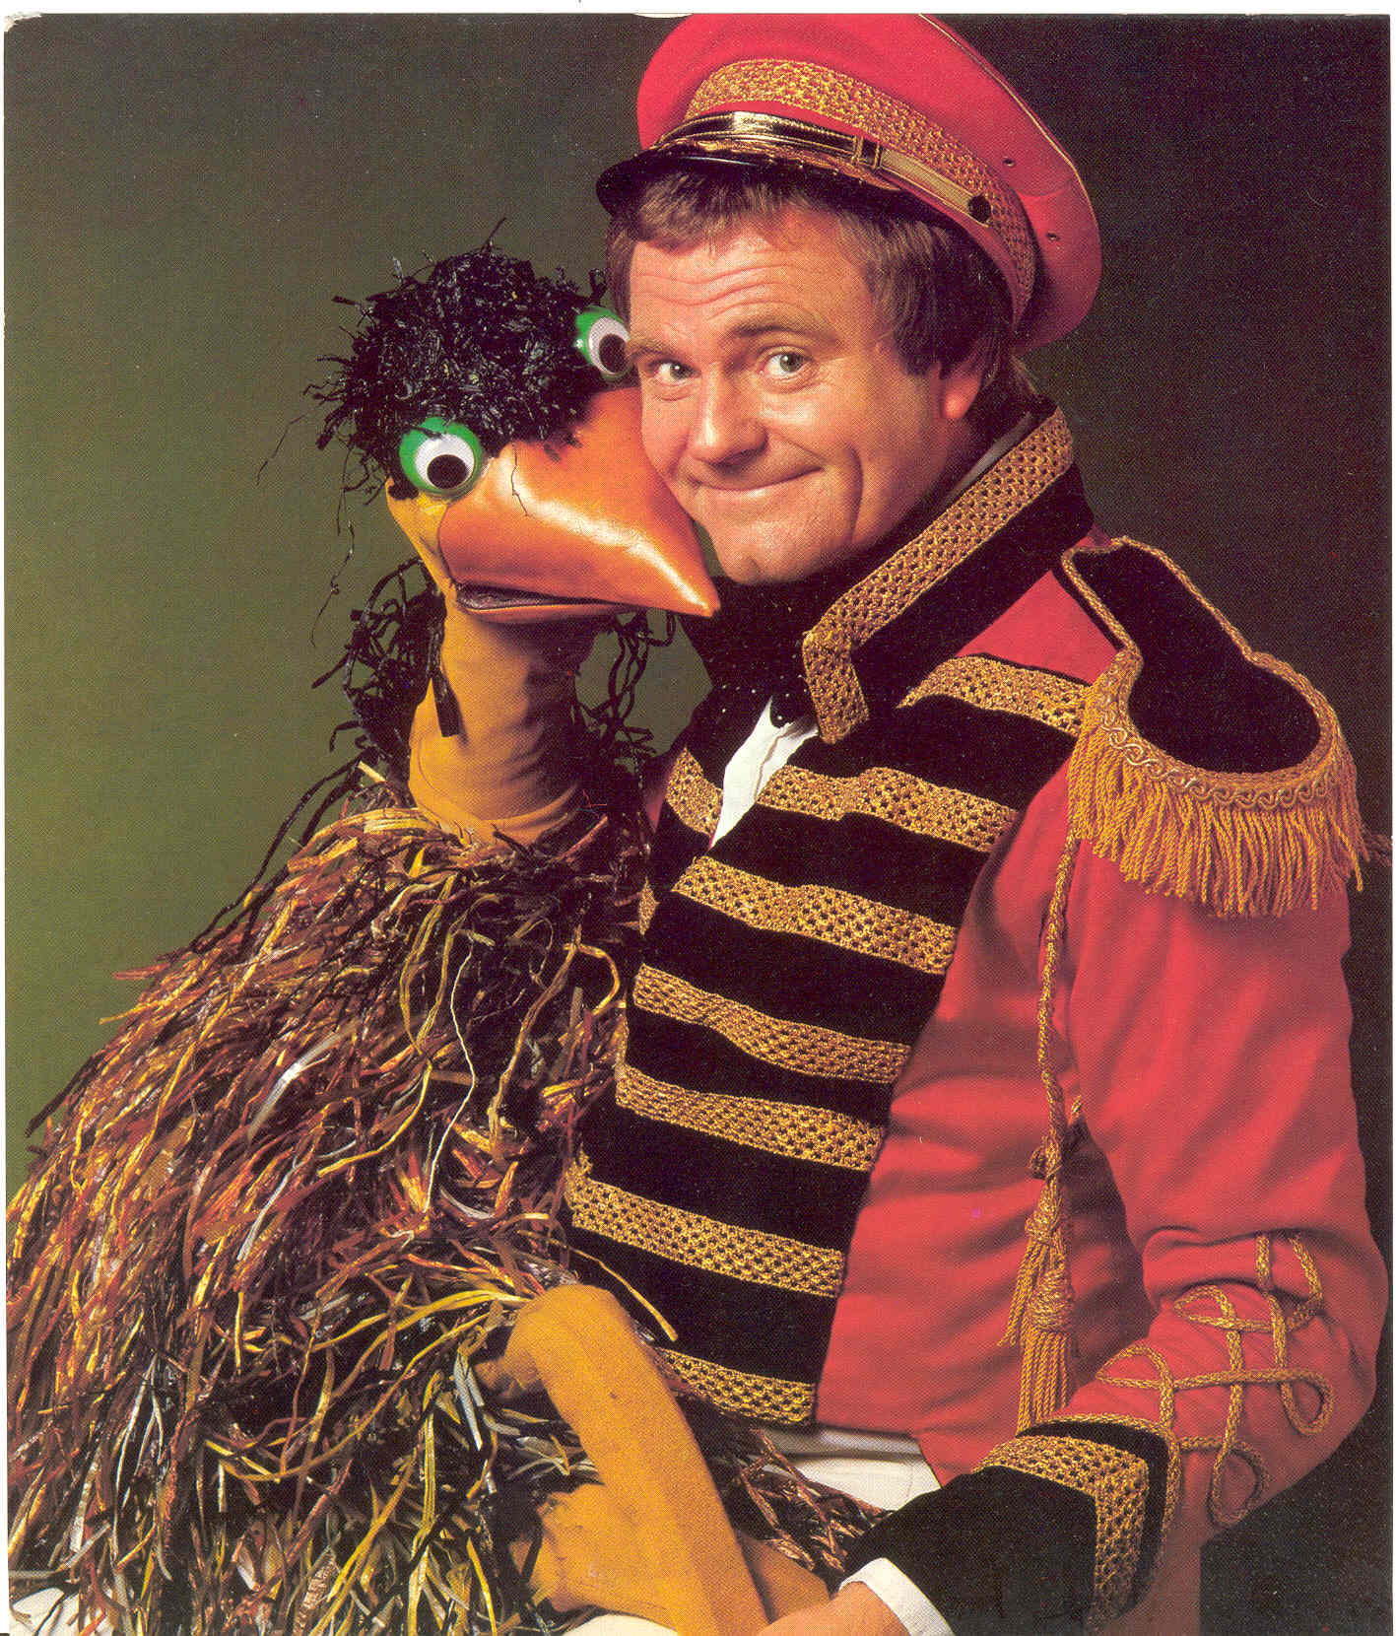

BOOKINGS &
AVAILABILITIES
CONTACT

HELEN MCGRATH
(02) 9597.5688
FOGARTY THEATRICAL

PRODUCTIONS PTY LTD

f

